Going Back to School
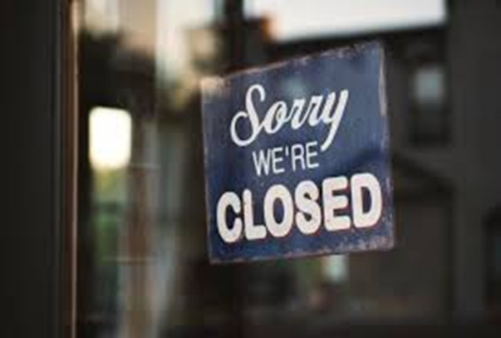
COVID-19 is a new virus that makes people unwell. COVID-19 is sometimes called coronavirus. Because it is new, lots of people have become ill with the virus. To help stop the virus from spreading, almost everyone has had to stay at home. Schools have been closed. Lots of other places have been closed too.

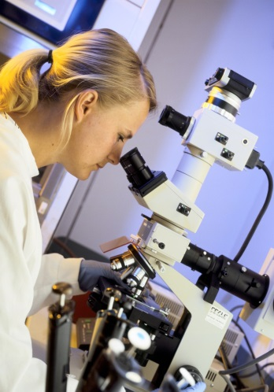
Scientists have been working hard to find out more about the coronavirus. Scientists have also been counting how many people have been getting ill with coronavirus. The number of people becoming ill with coronavirus is getting lower and lower. Scientists say it is now safe for most children to go back to school.

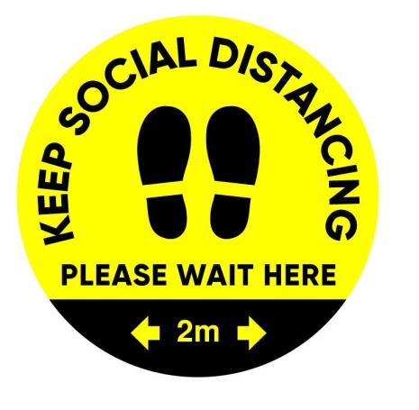
Because some people are still getting ill with the virus, it is important that we don’t get too close to other people when we are out of the house. Scientists say we should stay at least 2 metres away from people that we don’t live with if possible. There might be markings on the floor or signs at school to remind children where to stand or to keep away from others. At school it might not always be possible to keep away from other children. Scientists say this is ok. To help stop the virus from spreading children will have to stay in their groups or ‘bubbles’ instead. Adults at school will try to keep their distance from the children.
At some schools, adults and children might be wearing masks in some areas of the school. This is to help stop the virus from spreading. Masks are sometimes called face coverings. The adults at school will tell children if they need to wear a face covering. There may also be signs in the areas where face coverings need to be worn. Some people might not be wearing face coverings. This is because some people have special reasons why they cannot wear a face covering. My parents and teachers will tell me if I need to wear a face covering at school.
This means that going back to school might be a bit different than before. This is to keep everyone safe and stop the virus from spreading. These are some of the things that might be different when I go back to school (edit as appropriate):
- I will be in a different school.
- I will be in a different class.
- I will have a different teacher.
- I will be starting school at a different time.
- I will not be able to spend time with children who are in a different year group or different class from me.
- There won’t be as many children in the playground at break time.
- Lunchtime and break time might be at different times than before.
- There might be a one way system in the corridors and markings on the floor to tell me which way to go. If I am not sure what the markings mean I can ask an adult.
- Children might be sat further away from each other in the classroom or the desks might be placed differently.
- I might not be able to do some activities and clubs for a while.
- I might have to wear different clothes on a day I have PE so I don’t have to change at school.
- I won’t be able to bring toys, stationary or other objects from home.
- People might be wearing masks.
- I might have to wear a mask in some areas at school.
- I will be leaving school at a different time.

These are some of the things that will stay the same when I go back to school: (edit as appropriate)
- I will still go to the same school
- I will still have the same classroom
- I will still have the same teacher
- I will still be in a class with my friends
- Break time will still be in the same playground
- I will still have computer time
- I can still use the quiet area if I need a break

Scientists say it is now safe for most children to go back to school. School might be a bit different when I go back but lots of things will stay the same.

