Getting Used to Changes at School

I am going back to school. Things will be a little bit different at school than before.
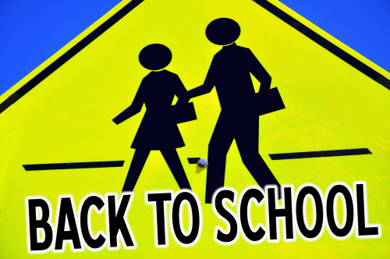

[you can replace this with a picture of your child’s school]

Going back to school might feel a little bit strange at first. This is ok. When I first started school everything was new and different. Over time I got used to this. I changed classes and teachers every year. I got used to this. I even changed schools. I got used to this too. (delete if not applicable). (Here you can also add a specific example of a change/transition that your child found difficult but learnt to cope with)


Going back to school will be a little bit different at first. I will get used to this, just like I got used to other changes at school. My parents and teachers will help me.

