What is a ‘bubble’ at school?
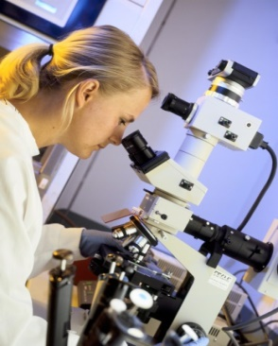

Coronavirus is a new virus that makes people unwell. Scientists have been working hard to find out more about the coronavirus. Scientists say it is now safe for most children to go back to school.

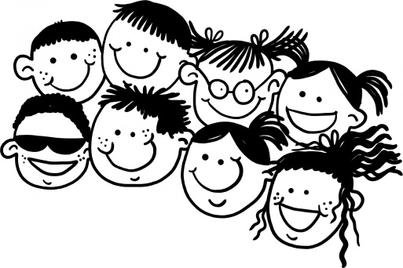

To help stop the virus from spreading children will have to stay in their groups all day. The groups of children at school might be called ‘bubbles’. Different groups or ‘bubbles’ will not be allowed to spend time together.

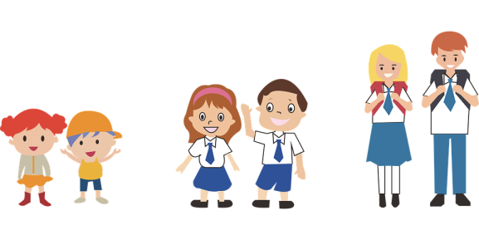
I will only be able to play and have lunch with children in my ‘bubble’. This means that I will not be able to play or have lunch with children who are in a different year group from me. I might not be able to play or have lunch with children who are not in my class (delete if appropriate). This is why some school activities and clubs will not be able to happen.

Scientists say it is now safe for most children to go back to school. To help stop the virus from spreading children will have to stay in their groups or ‘bubbles’. My parents and teachers will know what my ‘bubble’ is.

