What is a ‘bubble’ at school?
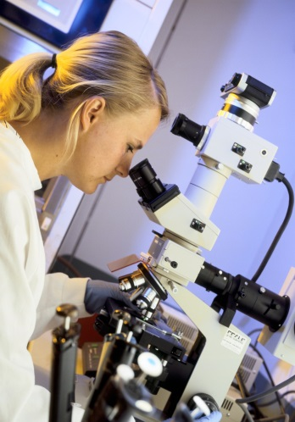

COVID-19 is a new virus that makes people unwell. Scientists say it is now safe for most children to go back to school. Because some people are still getting ill with the virus, it is important that we don’t get too close to other people when we are out of the house. Scientists say it is also important not to spend time with lots of different people.

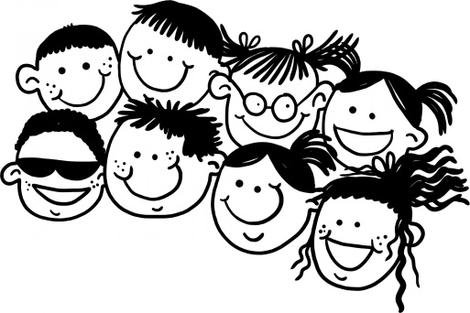

Going back to school might be a little bit different than before. To help stop the virus from spreading children in different year groups or different classes will not be able to spend time with each other. This means children will need to stay with their year group or their class during the school day. This might be called a ‘bubble’.

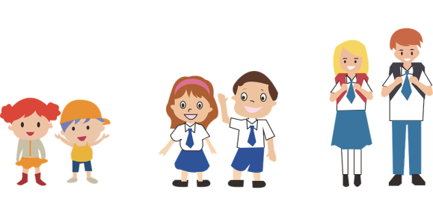
A ‘bubble’ means that each year group or class might arrive and leave school at a different time or use a different part of school building. A ‘bubble’ means that each year group or class might have their lunch or break time at a different time or in a different part of school building. A ‘bubble’ means that some activities and clubs will not be allowed to happen, as they mean that different year groups or classes would be spending time together.

Scientists say it is now safe for most children to go back to school. To help stop the virus from spreading children in different year groups or different classes will not be able to spend time with each other. This means that going back to school might be a little bit different than before.

