Going Back to School

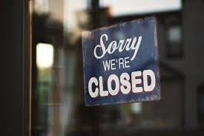
Coronavirus is a new virus that makes people unwell. To help stop the virus from spreading, almost everyone has had to stay at home. Schools and other places have been closed.

Scientists have been working hard to find out more about the coronavirus. Scientists say it is now safe for most children to go back to school.
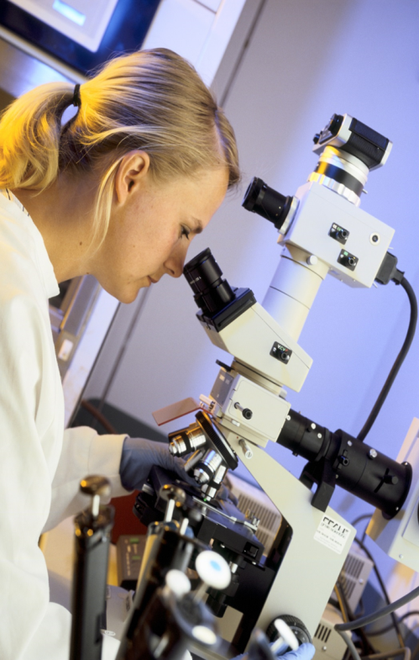

I am going back to school. Going back to school might be a bit different than before. This is to keep everyone safe and stop the virus from spreading. Many things will stay the same. My parents and teachers will know what will be different and what will stay the same. They can tell me.
(Insert picture of your child’s school here)

Scientists say it is now safe for most children to go back to school. Going back to school might be a bit different than before. My parents and teachers can help me.
If your child is a little bit older and you think they can manage a longer story, you can include the following list of things that will be different and things that will stay the same. Alternatively, you can use it separately or only pick out the most important information.
These are some of the things that might be different when I go back to school: (edit as appropriate and include relevant pictures)

- I will be in a different school.
- I will be in a different class.
- I will have a different teacher.
- I will be starting school at a different time.
- I will have to say goodbye to my parents at the school gate.
- I will not be able to spend time with children who are in a different year group or different class from me.
- There won’t be as many children in the playground at break time.
- Lunchtime and break time might be at different times than before.
- Children might be sat further away from each other in the classroom or the desks might be placed differently.
- There might be a one way system in the corridors and markings on the floor to tell me which way to go. If I am not sure what the markings mean I can ask a grown up.
- I won’t be able to bring toys, stationary or other objects from home.
- I might have to wear different clothes on a day I have PE so I don’t have to change at school.
- I might not be able to do some activities and clubs for a while.
- People might be wearing masks.
- I might need to wear a mask in some areas at school.
- I will be leaving school at a different time.

These are some of the things that will stay the same when I go back to school: (edit as appropriate and include relevant pictures)
- I will still go to the same school
- I will still have the same classroom
- I will still have the same teacher
- I will still be in a class with my friends
- Break time will still be in the same playground
- I will still have computer time
- I can still use the quiet area if I need a break

Scientists say it is now safe for some children to go back to school. School might be a bit different when I go back but lots of things will stay the same.
