Why are people wearing masks?
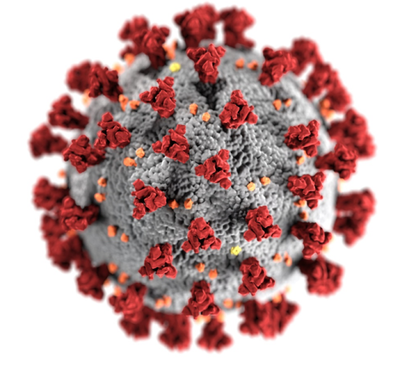
COVID-19 is a new virus that makes people unwell. COVID-19 is sometimes called coronavirus. To help stop the virus from spreading, almost everyone has had to stay at home.

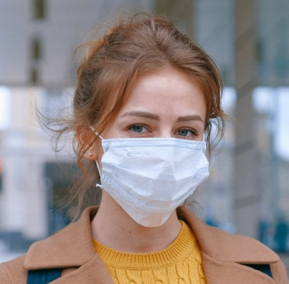
Scientists say it is now safe for some people to go out again. Scientists say that it is important to wear masks when we visit certain places. Masks help to keep people safe from the virus. I might see people wearing masks when I go out.
Masks may look like this:

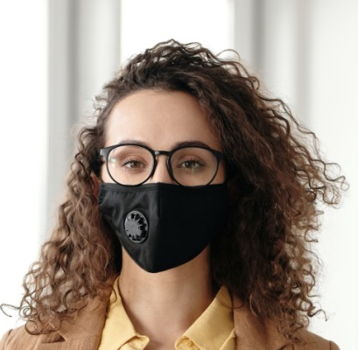
Or like this:

Or another different colour.

Some masks may have pictures or patterns on like this:
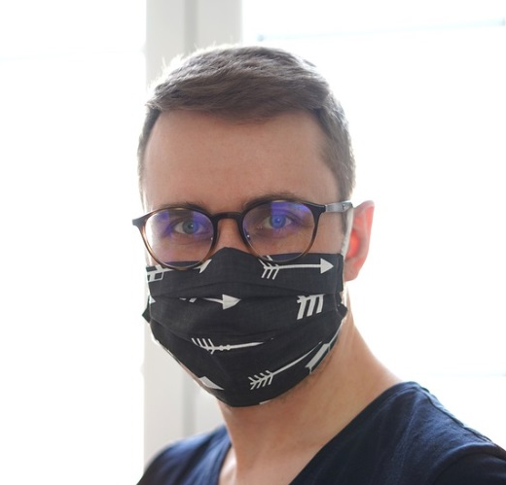

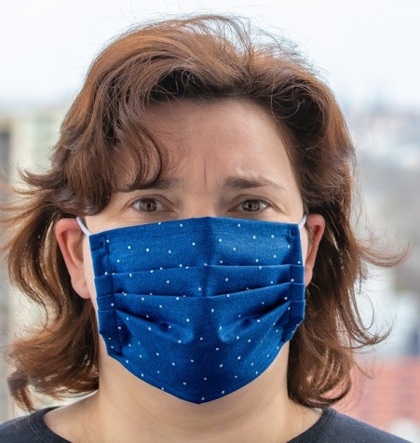
Or like this:

Or another different pattern.

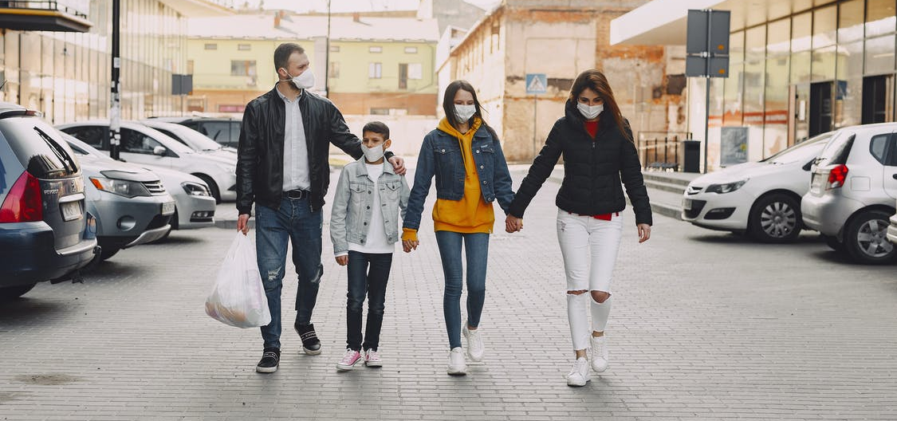
Mum or dad will know when we need to wear masks. I will try to wear a mask when I visit certain places. If me or my family already wear a face covering, I do not need to wear a mask as well.

Scientists say it is safe for some people to go out now. People might be wearing masks. Mum or dad will know when we need to wear a mask. Masks help to keep everyone safe and stop the virus from spreading.

