What is Social Distancing?

COVID-19 is a new virus that makes people unwell. COVID-19 is sometimes called coronavirus. Because it is new, lots of people have become ill with the virus. To help stop the virus from spreading, almost everyone has had to stay at home. Scientists also say we have to do ‘social distancing’.
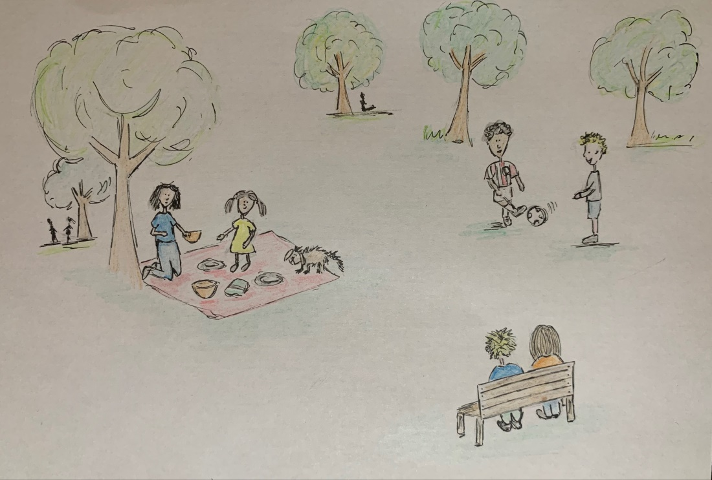

Social distancing means keeping away from people we do not live with. Scientists say we must stay at least 2 metres away from people that we don’t live with. This is about the same length as 2 shopping trollies. This is to help keep us healthy and stop the virus from spreading.
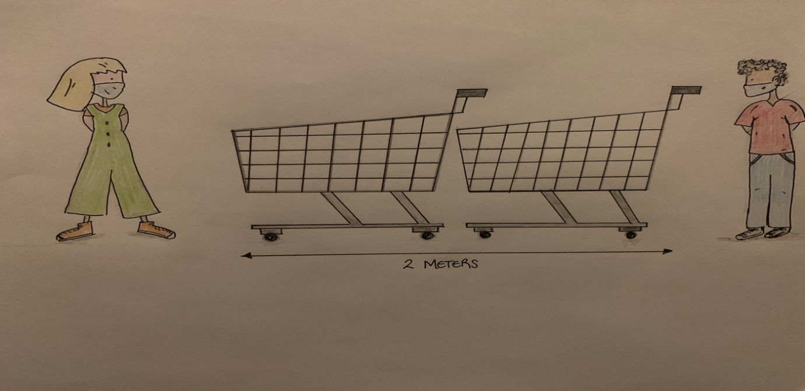

I will try to keep away from people that I do not live with. Mum or dad can help me. I can still talk to my friends and family on the phone or on a video call.
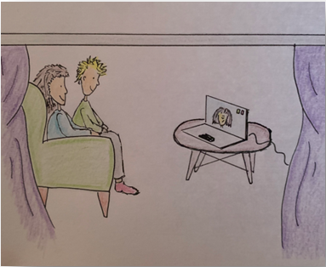

If I see someone I know, it is not safe for me to hug them or touch them. I can wave and say hello. I can talk to them as long as we stay 2 metres apart.
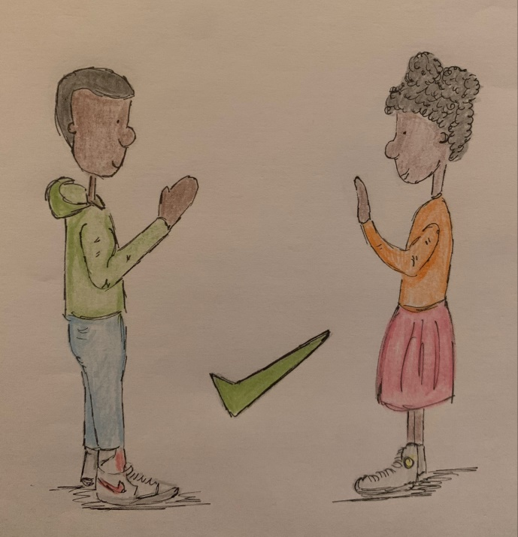
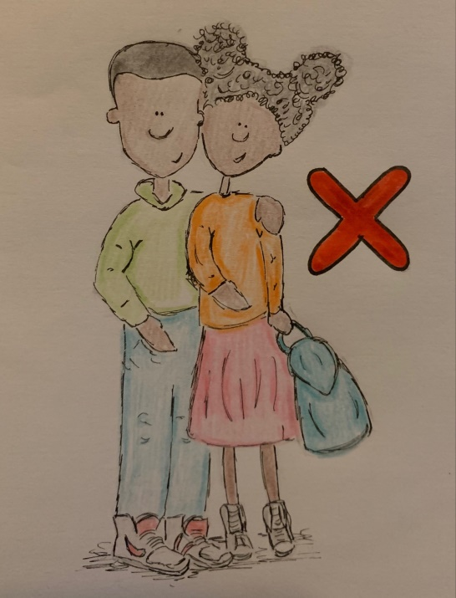

Social distancing means keeping away from people that we do not live with. This is to help stop the coronavirus from spreading.

