Why do we have to stay away from other people?
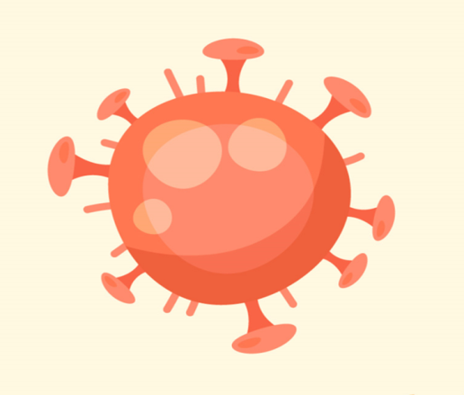

COVID-19 is a new virus that makes people unwell. COVID-19 is sometimes called coronavirus. Because it is new, lots of people have become ill with the virus.

Scientists say we have to keep away from people that we do not live with. This is to help keep us well and stop the virus from spreading.
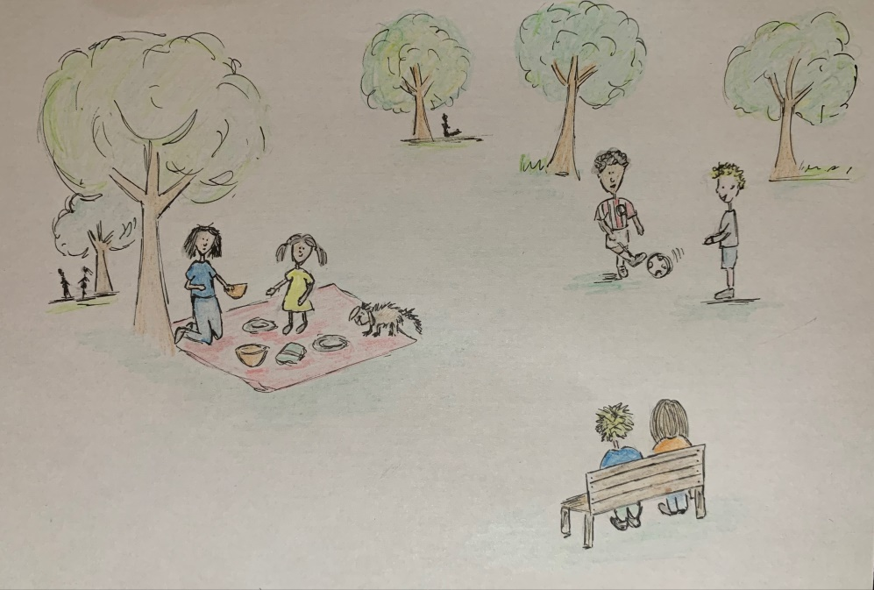

I will try to keep away from people that I do not live with. Mum or dad can help me. I can still talk to my friends and family on the phone or on a video call.
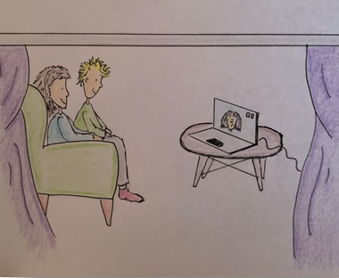

If I see someone I know, it is not safe for me to hug them or touch them. It is ok to wave and say hello.
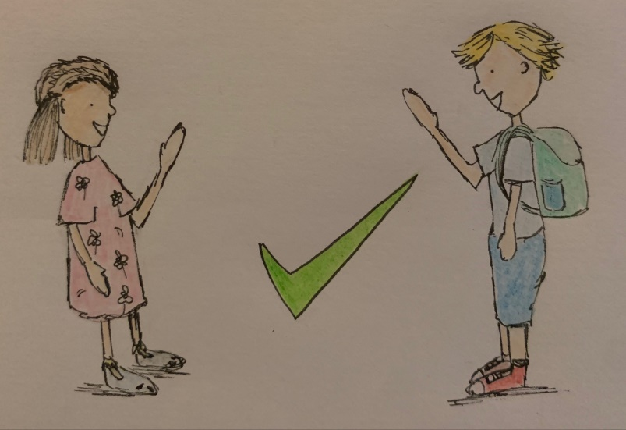
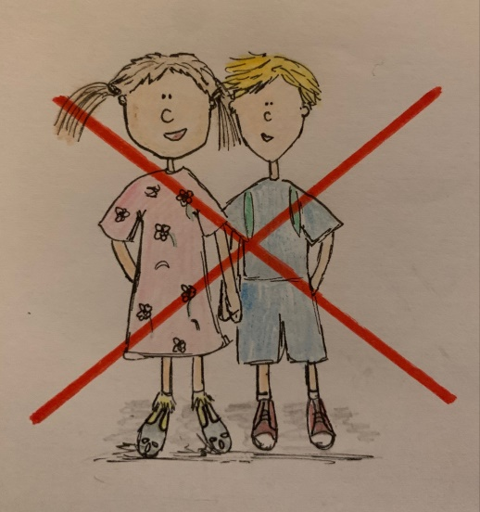

Scientists say we have to keep away from people that we do not live with. This is to help stop the coronavirus from spreading. Mum and dad can help me.

