Why is it safe to go out now?

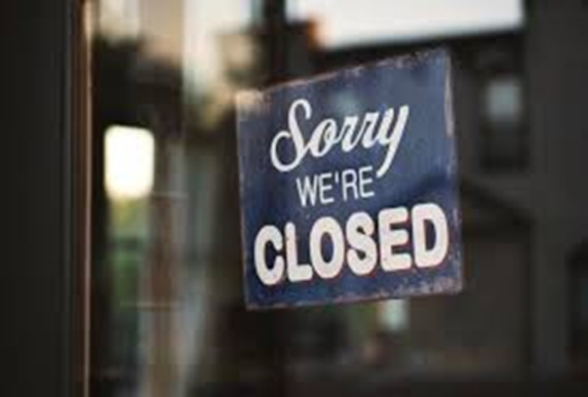
COVID-19 is a new virus that makes people unwell. COVID-19 is sometimes called coronavirus. Because it is new, lots of people have become ill with the virus. To help stop the virus from spreading, almost everyone has had to stay at home. Schools have been closed. Lots of other places have been closed too.
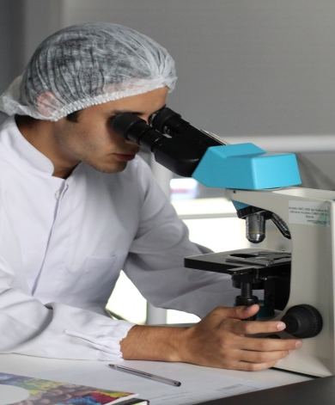
Scientists have been working hard to find out more about the coronavirus. Scientists have also been counting how many people have been getting ill with coronavirus. The number of people becoming ill with coronavirus is getting lower and lower. Scientists say it is now safe for some places to re-open. Not everywhere will be open straight away. Mum or dad will know which places we can go to
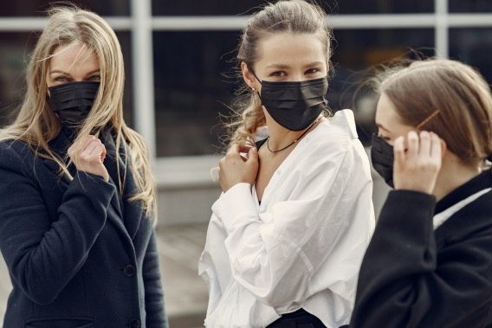
Scientists say that certain places can re-open if people wear special masks. Masks help to keep everyone safe and stop the virus from spreading. Mum or dad will know when we need to wear a mask.

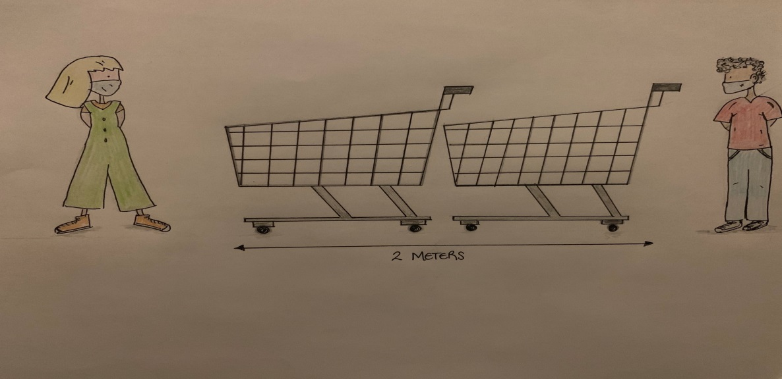
Because some people are still getting ill with the virus, it is important that we don’t get too close to other people when we are out of the house. Scientists say we must stay at least 2 metres away from people that we don’t live with. This is about the same length as a 2 shopping trolleys.

It is still important for everyone to wash their hands regularly to stop the virus from spreading. I will try to wash my hands with soap and warm water for 20 seconds:
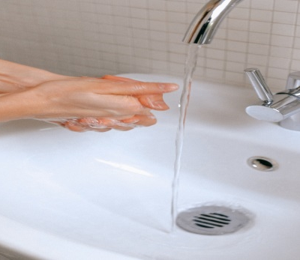
- Before I eat
- After I use the toilet
- When I get home
- After I cough or sneeze

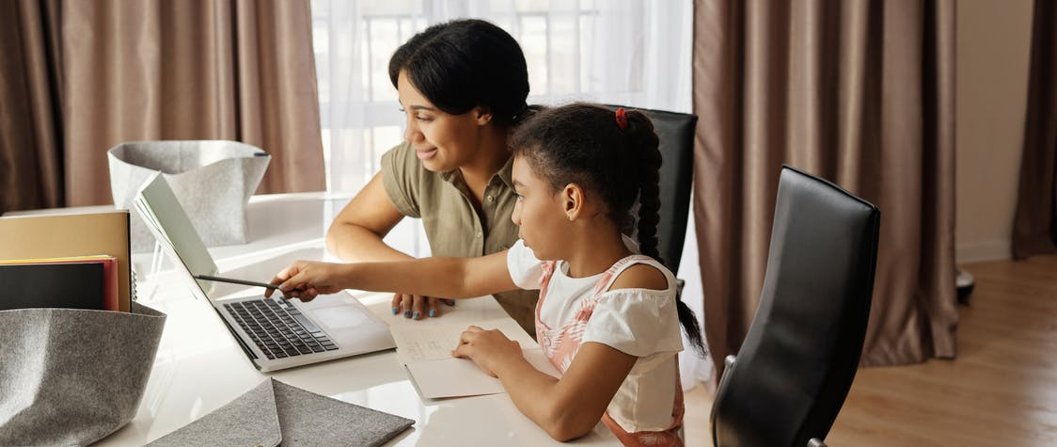
My Mum or Dad will show me how to wash my hands carefully. There might be other times when I need to wash my hands. Mum or dad will remind me when it is time to wash my hands.
Scientists will keep counting the number of people getting ill with coronavirus. If lots and lots of people start becoming ill again, everyone will have to stay at home again. This is to keep everyone healthy and stop the virus from spreading. Mum or dad will tell me if we have to stay at home again.
Scientists say it is safe for some people to go out now. We can only go to certain places for now. Mum or dad will know where we can go. We need to keep away from people we don’t live with and wash our hands regularly. People might be wearing masks. This is to keep everyone safe and stop the virus from spreading.
