Why is it safe to go out now?

COVID-19 is a new virus that makes people unwell. COVID-19 is sometimes called coronavirus. Because it is new, lots of people have become ill with the virus. To help stop the virus from spreading, almost everyone has had to stay at home. Schools have been closed. Lots of other places have been closed too.
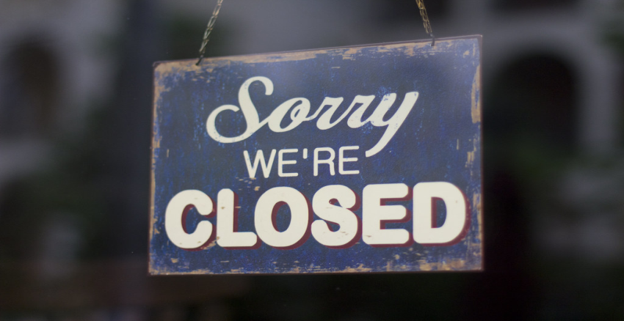



Scientists have been working hard to find out more about the coronavirus. Scientists have also been counting how many people have been getting ill with coronavirus.


The number of people becoming ill with coronavirus is getting lower and lower. Scientists think it is now safe for some people to go out. Scientists think it is now safe for some places to re-open. Not everywhere will be open straight away. Mum or dad will know which places we can go to.

Scientists say it is safe for us to go out now. We can only go to certain places for now. Mum or dad will know where we can go.


