Peak Expiratory Flow (PEF) monitoring.
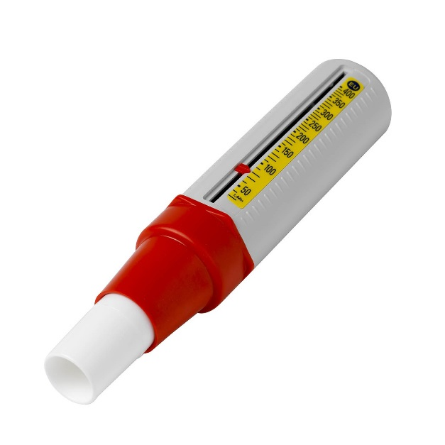
Counter.
This red counter moves when you blow into the monitor. Push it back to zero after each blow.

Mouthpiece
Ensure your lips are sealed around the mouthpiece.

In the absence of doing our regular lung function tests in our respiratory clinics, we would like you to use a Peak Expiratory Flow (PEF) monitor.
This helps provide some basic information about how quickly you can blow air out of your lungs and give us an indication on how well your asthma is controlled at the moment.
You will be provided with a PEF monitor and we will ask you to perform the PEF test once a day at the same time of day for a few days to obtain your baseline readings. It is important to note that we are trying to monitor any change (decrease) in lung function. Repeating the PEF test on a daily basis when you are well will help you learn what is normal for you.
Please note: The expected “normal” result will be dependent on height, age and sex, and therefore will be unique to you. You should NOT compare your results to anyone in your family or friends as they will have different expected results. For infection control reasons you should not allow anybody else to use your PEF monitor.
How to use your Peak Flow monitor:
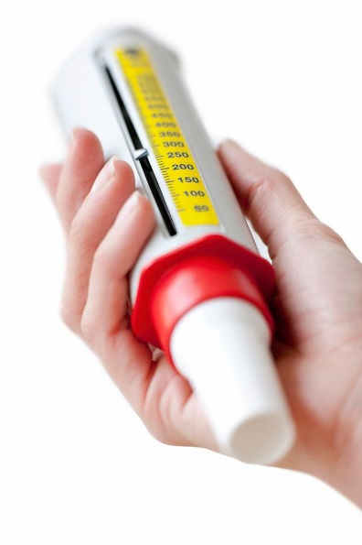
- Ensure the counter is pointing to zero (push it back to zero)
- Ensure your fingers do not get in the way of the counter
- Sit up straight
- Take in a deep breath (as big as possible)
- Put the mouthpiece into your mouth and seal with your lips
- Blow as hard and as fast as possible into the monitor
- Record the number next to the counter
- Reset to zero
- Repeat three times
A demonstration of how to use your PEF can be found on the asthma UK website:
https://www.asthma.org.uk/advice/manage-your-asthma/peak-flow/
Please keep a record of your usual PEF readings when you are well, so we can monitor any changes (i.e. decreases) in your PEF when you aren’t well. Please contact a member of the respiratory team (asthma nurses: 0114 2717414) if you are feeling unwell and your PEF has decreased.

