
Guidance for prospective governors
Sheffield Children's NHS Foundation Trust

Governor Elections 2021
Be the difference …
Become a governor
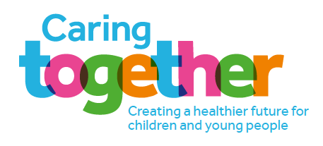

Welcome from the Chair

If you have registered as a member of the Trust you’ll already be interested in your local hospitals - the quality of care we offer, the modern services we provide, as well as our plans for future improvement and development.

With this in mind, have you thought about further supporting your local NHS trust by becoming a governor?

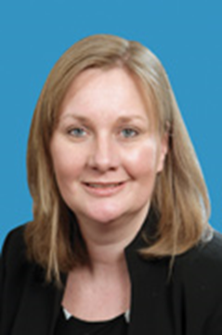
Our governors play a vital role representing the public. They influence the Trust to make improvements, develop services and also hold non-executive directors to account for the performance of the Board of Directors.

Being elected as a governor doesn’t just mean coming along to a council meeting every quarter (although you’ll do that to assess how well the Trust is doing). Governors at the Children’s also play an active role in improving patient services, checking cleanliness in the hospitals, and engaging patients to find out what they really think.

Our governors speak to patients to get the ’real picture’ and they tell us when a problem needs to be put right. They represent our members and the local community to ensure we are delivering on our promises and improving all the time for the good of patients.

We are looking for people of all ages and from different backgrounds across Sheffield to become governors.

This year we need public governors to represent Sheffield, as well as staff governors for non-clinical and nursing and midwifery seats.

This booklet explains everything you need to know. All nominations for the elections must be received by 5pm on 14 June 2021.

Even if you don’t think being a governor is for you, it’s still possible to have your say on the Trust’s future. All members will receive a voting pack – so use your vote and make it count!
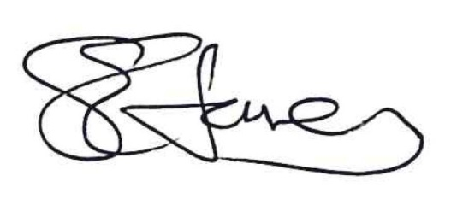
Sarah Jones
Chair

Who we are and what we do

Sheffield Children’s NHS Foundation Trust is a dedicated children’s hospital trust which provides integrated healthcare for children and young people, including community and mental health care as well as acute and specialist services. We see children from 0-16 in most cases and in some cases up to 18.

We provide a full range of services for residents of Sheffield and South Yorkshire as well as specialised services for patients from across the United Kingdom.

Demand for our services is growing and we are increasingly delivering healthcare to patients over a wider geographical area as our reputation for providing outstanding specialist care grows. We have some of the best medical and surgical services for children in the country.

We employ more than 3,500 people and strive to recruit and retain the best doctors, nurses, allied health workers and other staff. The commitment of our employees is key to the Trust’s success and reputation. We are currently rated ‘Good’ by the Care Quality Commission.

The Trust is committed to being a leader in the field of training and research in children’s healthcare and we continue to deliver a strong portfolio of research and product innovation.


Above: shows England Netball captain Ama Agbeze MBE during a recent visit to Sheffield Children’s in 2019.

Our sites

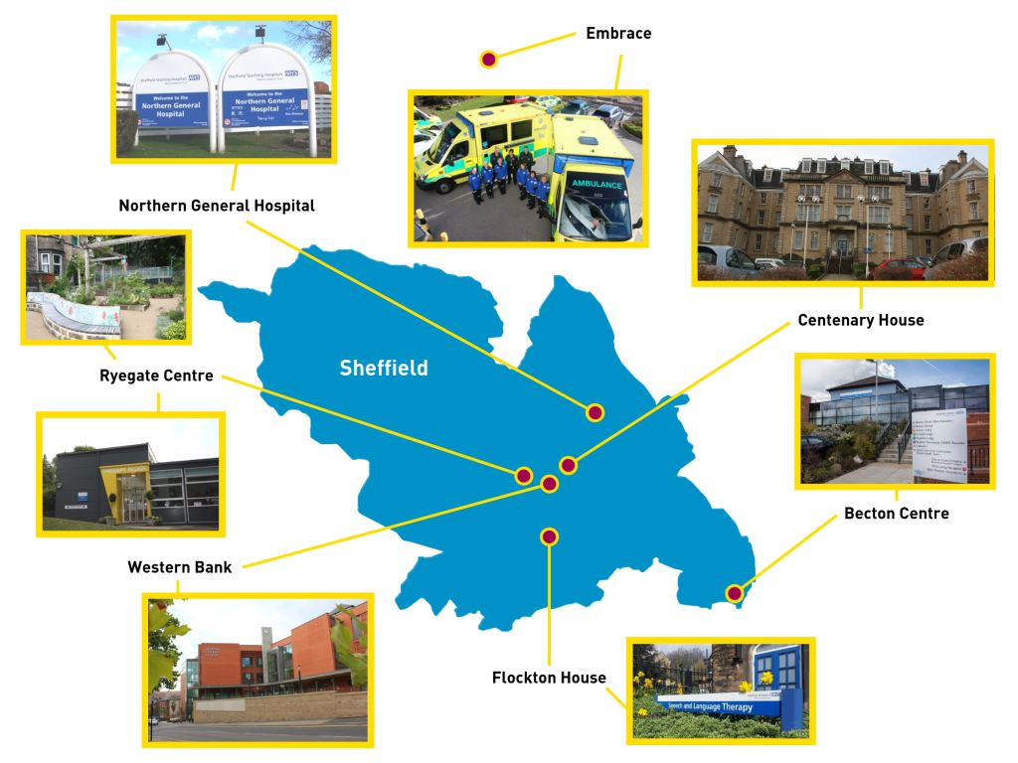

The acute hospital site is on Western Bank near Sheffield City Centre. This is home to our inpatient wards, theatres, critical care unit, emergency department, outpatient clinics, research department, laboratories and administrative offices.

Our other sites include:

• Becton Centre for Children and Young People, Beighton;
• Centenary House, Upperthorpe;
• Flockton House, Nether Edge;
• Northern General Hospital, Sheffield;
• Ryegate Children's Centre, Crosspool.

In addition, we run Embrace, an accredited critical care transport service based in Barnsley.

The role of the governor

As a governor your role will be to engage with our members and make sure their voice is heard. You will be required to:

• hold non-executive directors (NEDs) to account for the performance of the Board and represent the interests of our members and the public;
• appoint and, if necessary, remove the Chair and non-executive directors;
• set the pay and conditions of employment for the chair and NEDs;
• approve the appointment of the Chief Executive;
• appoint or remove the Trust’s auditors;
• approve significant transactions, mergers, acquisitions, separations or dissolutions.

As a governor you will receive agendas and minutes for Board meetings and will have the power to require directors to attend meetings to answer questions.

Governors are expected to attend the formal Council of Governors meetings which take place at least four times a year, as well as the Annual Members’ Meeting in September. During the pandemic, our meetings have been held virtually and we have seen a positive increase in engagement during this time.

Governors also attend briefings, training events and Back to the Floor visits. Governors will be paid back for all reasonable expenses incurred as part of discharging their duties.

Being a governor is not about ‘rubber stamping’ decisions made by the Board of Directors. The Council of Governors advises the Board of Directors as to public opinion and are guardians of the public interest. They take the temperature of the organisation and can challenge Board decisions.

As the key link between the Trust and the communities that we serve, governors advise the Trust about the needs of patients and the community, and suggest ways to involve patients and the public in developing and delivering services.

As ambassadors, governors promote the work of the Trust within their constituencies. This may involve attending and speaking at local events or holding local surgeries for patients, members of the public or staff. As guardians, governors make sure that the Trust is run in a way that reflects its purpose, and complies with the obligations placed on it.

All governors must sign a declaration agreeing to follow the Trust’s Code of Conduct for governors.

How the governors are structured

The basic governance structure of all NHS foundation trusts includes members, the Council of Governors and the Board of Directors. The Chair of the Board of Directors is also the Chair of the Council of Governors.

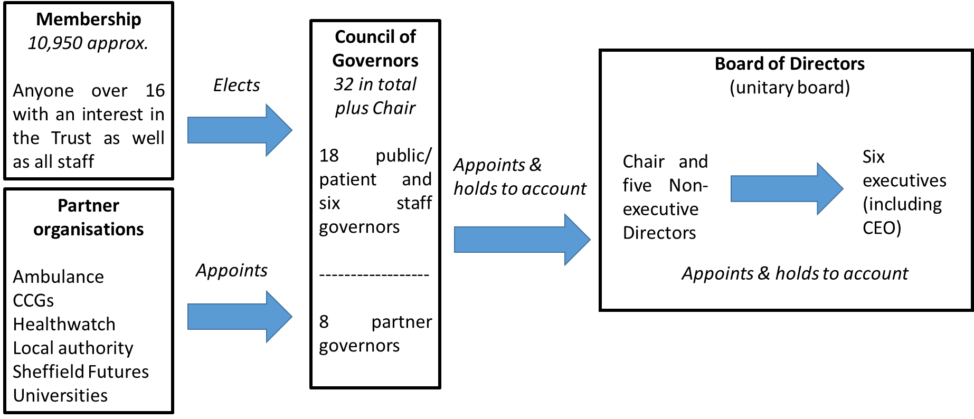

Members

Being a member means keeping up to date with developments and having a say about how the Trust is run. At the moment there are around 10,950 Trust members spread throughout Sheffield and beyond.

Board of Directors

Our Board of Directors is responsible for the management of the Trust and, with input from the Council of Governors, sets its future direction. They are also responsible for monitoring performance against national, regional and local objectives and ensuring the highest levels of standards and performance.

There are 13 voting members of the Board of Directors made up of seven non-executive directors including the Chair and six executive directors. Sarah Jones was appointed Chair of the Board from 1 September 2016, and was reappointed in 2019.

One of the key roles of the non-executive directors is to obtain assurance that the correct governance, policies and procedures are in place and that performance is being appropriately managed at operational level. One of the ways it does this is through three board committees responsible for: people and performance; quality; and risk and audit.

There are three other board committees responsible for appointing and remunerating executive directors, for working with partner trusts in South Yorkshire and Bassetlaw and for managing the charitable funds of the Trust.

Council of Governors

The Council of Governors is made up of 32 governors who are either elected by staff or members of the Trust or appointed by stakeholder organisations such as the clinical commissioning groups, local authorities, voluntary sector or universities.

Public members (elected)
Sheffield  Rest of South Yorkshire (Barnsley, Doncaster & Rotherham)  Rest of England and Wales  North Derbyshire (Bolsover, Chesterfield and NE Derbyshire) | 12  3  2  1
Staff members (elected)
Medical and Dental  Nursing and Midwifery  Other Clinical Healthcare  Non-Clinical | 1  2  2  2
Partner organisations (appointed)
Sheffield City Council  Sheffield Clinical Commissioning Group  Sheffield Futures  Sheffield Hallam University  Yorkshire Ambulance Service  University of Sheffield | 2  1  1  1  1  1

Governors have two key duties:

• To hold the non-executive directors to account for the performance of the Board; and
• To represent the interests of our members and the public.

How do I stand for election?

You need to be 16 or over and registered as a member of the Trust to stand for election as a governor. You can check whether you are a member by contacting the Corporate Affairs Team on 0114 2717593.

You don’t need any formal qualifications to be a governor. Some governors have previous experience of working with their local communities while others bring skills that they have gained through paid or voluntary work.

Once elected, the Trust has the duty to ensure that governors are equipped with the skills to perform this role. Full induction and training required will be provided. Whilst there are no qualifications needed, you may not become an elected governor if:

- you have been declared bankrupt;
- you have made a composition or arrangement with, or granted a trust deed for, creditors and have not been discharged in respect of it;
- you have been sentenced to prison for three or more months within the last five years.

There are other reasons why you may not be able to be a governor so please contact the Corporate Affairs Team on the number above if you’d like to stand for election but think there might be an issue.

Once nominations are open on 14th May you can request a pack from the Corporate Affairs Team by emailing matthew.kane1@nhs.net or ringing 0114 2717593. Alternatively you can submit your nomination online at: www.cesvotes.com/sch2021.

How do the elections work?

An external agency runs the elections to make sure that they are completely impartial.

Nominations and ballot papers are handled by this external agency and the agency sends out information to all members to enable them to vote.

Candidates are given the opportunity to write a brief statement about why they are standing for election, to introduce themselves to members and encourage people to vote for them.

Six seats are up for election in 2021; successful candidates will be elected for a three year term of office.

Vacancies are as follows:

• Four seats in Public - Sheffield;
• One seat in Staff - Non-clinical;
• One seat in Staff - Nursing and Midwifery.

Ballot papers will be sent to all registered members within the constituencies where an election is to be held. A ballot will only be held where there are more nominations than vacant seats.

The election system to be used is known as Single Transferable Vote (STV). The 2021 election timetable is as follows:

- Notice of election/nominations open: 14 May 2021
- Nomination deadline: 14 June 2021
- Summary of nominated candidates published: 15 June 2021
- Final date for candidate withdrawal: 17 June 2021
- Notice of poll published: 5 July 2021
- Voting packs despatched: 6 July 2021
- Close of ballot: 29 July 2021
- Declaration of results: 30 July 2021
- Term of office starts: 29 September 2021

A candidate may not incur any expenses or make a payment of any nature for the purposes of an election.

should I become a Governor?

If you have any further questions please contact the Corporate Affairs Office on 0114 2717593

Sheffield Children's NHS Foundation Trust
Western Bank
Sheffield
S10 2TH

Stay up to date with the elections at www.cesvotes.com/sch2021

